Test1

Cover script

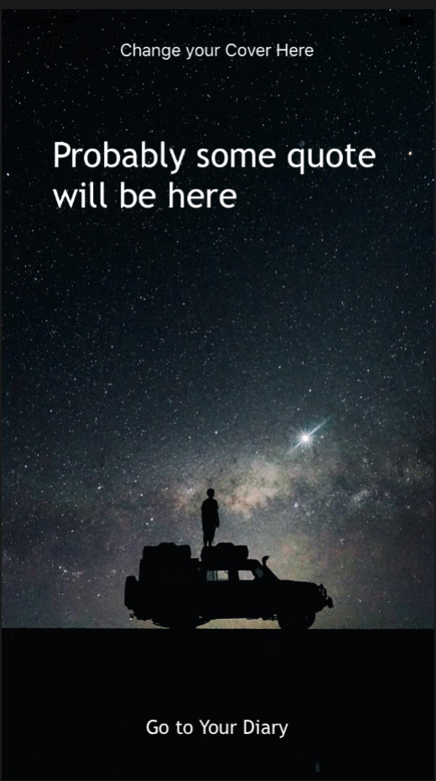 -> 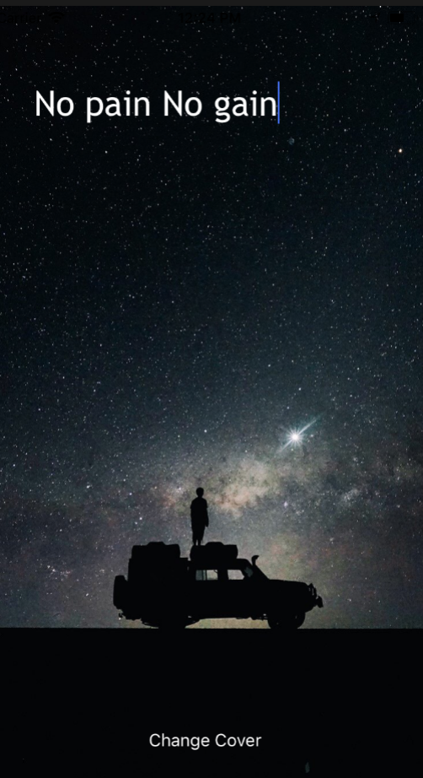 -> 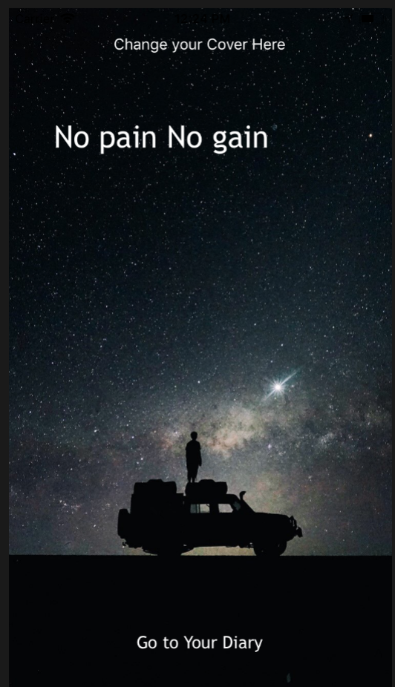

Before the users actually goes into their diary it shows the quote that they set before. Users can change the quote by change your cover here button.

Test2

Font , city and the weather

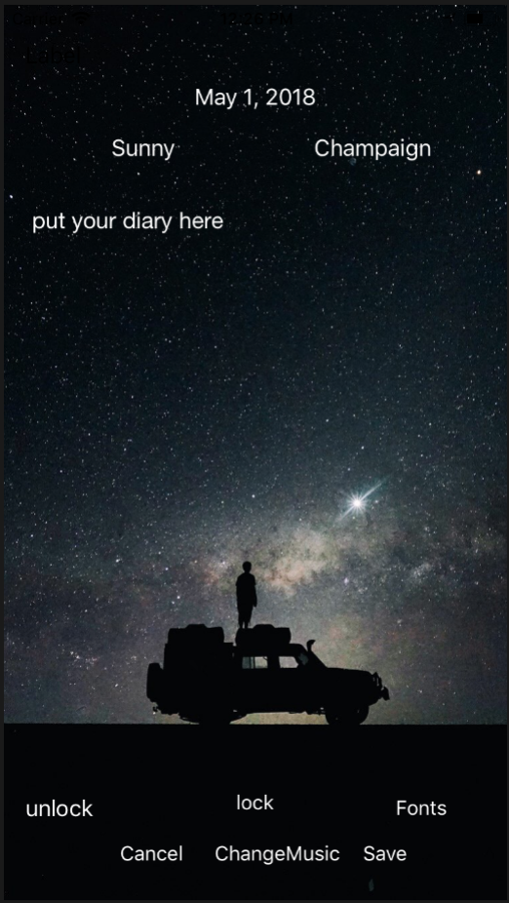 -> 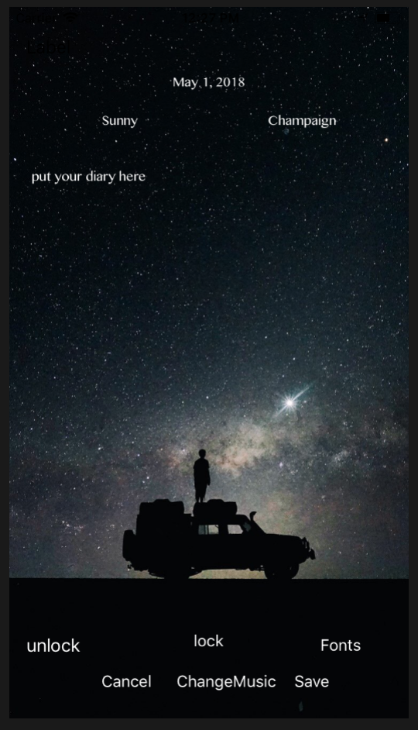 -> 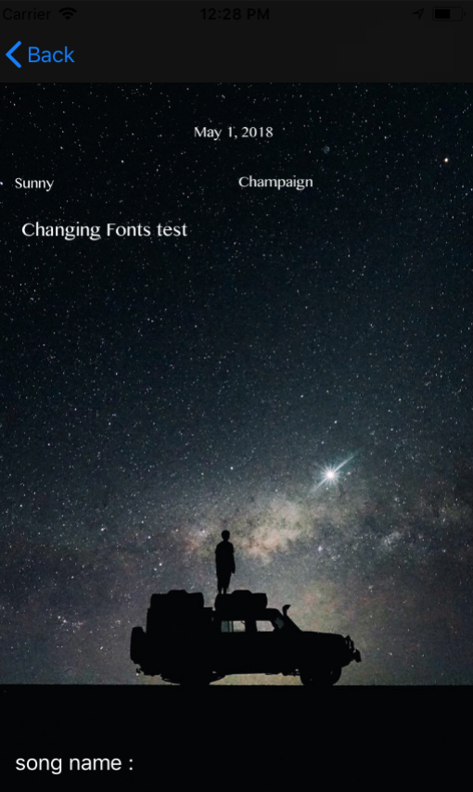

When the user write a diary, they can set the font that they want to. If the font is chosen, the read view controller shows the diary with the fonts.

In addition, I can get the current location and the current location’s weather on the add and read diary view controller.